**AWS IAM WorkItems**

* Create an IAM user with programmatic access and administrator Access and configure the user in the AWS CLI
* Now lets try to create 2 users using AWS CLI <https://docs.aws.amazon.com/cli/latest/reference/iam/>

aws iam create-user --user-name ironman

aws iam create-user --user-name thor

* Now lets create a group called as DBAdmins

aws iam create-group --group-name dbadmins

* Now lets attach a Policy AmazonRDSFullAccess to the group

aws iam attach-group-policy --group-name dbadmins --policy-arn 'arn:aws:iam::aws:policy/AmazonRDSFullAccess'

* Now lets add users to the group

aws iam add-user-to-group --group-name dbadmins --user-name ironman

aws iam add-user-to-group --group-name dbadmins --user-name thor

* Now lets try to create access key for the user

aws iam create-access-key --user-name ironman > ironman.json

aws iam create-access-key --user-name thor > thor.json

* Rotating IAM Credentials 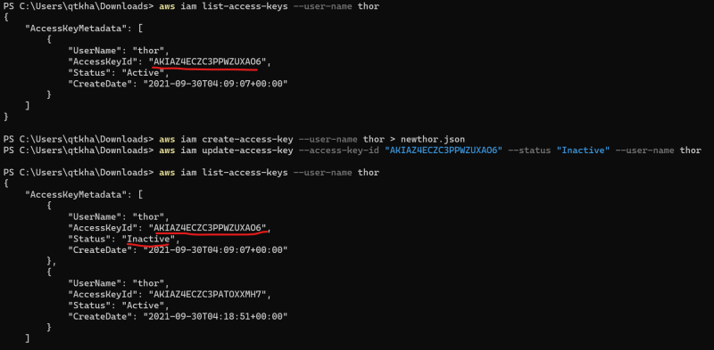
* Now delete the old access key 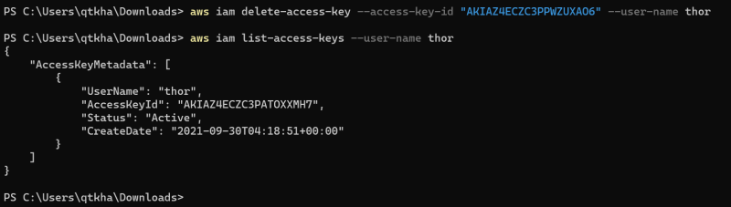
* Exercise:
  + Write a shell script to rotate credentials for all iam user except "admin"
  + Note: to get the list of user aws iam list-users --query "Users[*].UserName"